Do you know who is watching your child?
What are kids posting on their YouTube channel?
Do you know?
Having a YouTube channel may be a fun way for your child to express themselves, helping them develop skills sets such as acting, broadcasting and editing. Some even trying to be the next big YouTube star with millions of followers—but do you actually know what they’re posting and who is watching them?
Tips to keep your children safe on YouTube
Register using a parent's email account:  If your child is under the age of 13, they are required to use a parent’s email to set up an account with the parent’s consent. | Use a screen name instead of a real name:  For privacy, make sure your child uses a fictitious (made up) name. They should NEVER disclose their personal information such as address, phone number, town or school name. | Turn off ability to comment:  Inviting comments could lead to cyberbullying, trolling and much more. Limit this problem by disabling comments completely
Monitor videos:  Before your child starts posting YouTube videos, check out what they are doing on the videos. Make sure it’s something you feel comfortable with and it is appropriate for others to view it.  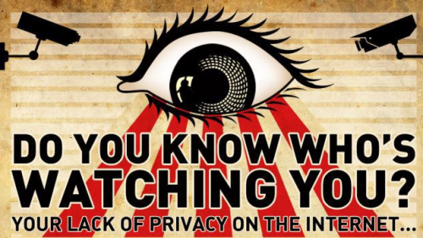 | Sign a family contract on house rules for social media and mobile device use:  It’s a good foundation for an overall conversation about electronic and social media usage | Change the privacy settings to private or unlisted: YouTube gives you 3 choices -  • PUBLIC which is the default setting  • PRIVATE means that only you and those you invite to view videos can see what you post.  • UNLISTED means your video will not come up in search results.
Having conversations with your child about online safety, using parental controls, and creating the right settings gives today’s digital parent peace of mind while still allowing your children the freedom to express their creativity. Remember….being open, honest and taking an interest in your child’s online activities is key to understanding the every changing online world that poses both risk but also enjoyment when used safely.
The key message for Safer Internet Day 2019 is: ‘Together for a better internet’
Apps to be aware of… 
Tiktok was the world’s most downloaded app in the first quarter of 2018. It was made by the same owners of music.ly so children who had an account on this will automatically be transferred over to Tiktok. It allows users the ability to watch musical clips, create short clips up to 60 seconds and add special effects to them.
The Risks | Prevention
The app, similar to Twitch, is meant for children 13 and over. Nonetheless, children at Conway have stated that they use the app. By default, all the accounts are public allowing anybody to view what your child shares. Also, strangers can potentially comment on users’ videos and send them private messages. | In the settings, it is possible to select a ‘restricted mode’ to filter inappropriate content on the app. Accounts can be set to ‘private’ so that all videos can only be seen by the creator and no one else on the platform. With a private account, you can approve or deny users and limit incoming messages to followers only.

Twitch is a live video game website meant for children who are 13+. However, children at Oakfield have stated that they are using Twitch. It allows users to watch playbacks of games being played by other people. It can also live stream their own games, and allow them to chat to other gamers. Users can follow channels and games they want to keep track of. Twitch allows live streaming.
The Risks | Prevention
As the content is live streamed censoring is very challenging. Thus, children may be exposed to inappropriate language. Also, children live streaming themselves could potentially mean that strangers are watching and listening to their conversations. Strangers may also send messages and communicate with them. | The majority of the above risks can be avoided through setting up parental controls and adjusting their settings. First you can tick a box to ‘block messages from strangers’. If your child is streaming their own videos, they can moderate the messages they receive in the comment box to restrict inappropriate language. However, anybody can still watch your child and listen to their conversations which could potentially be dangerous. For example, children may mention the area in which they live, the school they go to etc. Therefore, we strongly advise your child not to live stream their content and politely decline if someone requests to include them on a live stream that their friend is recording. Clear instructions of prevention strategies are available via google.



